SASS Basics

Sass is essentially programming for CSS. It’s main intentions are to increase readability and decrease repetition.

It is written in a .scss file, and then compiled to a .css file WHEN? HOW?

Sass is loosely an OOP (Object Oriented Programming) Language.

$background = beige;
@mixin background-image-config($image: default) {
background-image: url(#{$image}.jpg);
background-repeat: no-repeat;
}

.container-fluid {
background-color: $background;
height: 100%;
width: 100%;
@include background-image-config(“space-rocket”);
.header {
border-bottom: solid 4px black;
.title {
font-family: roboto, serif;
color: green;
&:hover {
color: red;
}
}
}
}

Nesting:
One excellent feature of SASS is nesting, which greatly reduces the amount of repetition and difficulty of reading, as it functions much more like HTML, in that elements can be nested inside their parent elements.

Mixins:
Mixins are reusable blocks of code, intended to be used when using the same styling on multiple elements, requiring less repeated code, and allowing the style of all to be edited from just one line.

It can be passed a parameter, in the same way a function can be, and which will then process and compile.

Mixins should only be used when you want to pass a parameter.

Declaring Variables:
Variables can be any type of:
- Numbers
- Colours
- Strings
- Booleans
- null
- Lists
- Maps

Variables are declared using the ‘$’ symbol.
$total = 10;
$best-color = red;

Math, Operators:

All standard operators work: + , - , * , / , %

$total = ($variable + 10) * 1.2;

Some surprising things can be achieved using SASS:
$brightGreen = rgb(0,255,0);
$newColour = $brightGreen + blue;

IF statements:
IF statements can be declared in both variables and Mixin blocks.

IF statement:
width: if( $condition, $value-if-true, $value-if-false);

Mixin block;
@mixin deck($suit) {
@if($suit == hearts || $suit == spades){
color: blue;
}
@else-if($suit == clovers || $suit == diamonds){
color: red;
}
@else{
//some rule
}
}

@Extend:
A common problem in HTML is needing to specify multiple classes to apply all wanted styling to an element, which makes it difficult to maintain.
The SASS solution to this is @extend.

%Placeholders:
Placeholders are intended to be used with @extend, to prevent the extended class from being compiled into the .css document.

SASS uses % to denote a placeholder, In the same way that . / # denotes a class / id.

%absolute {
position: absolute
}

.title {
@extend %absolute;
}

Sustainability:
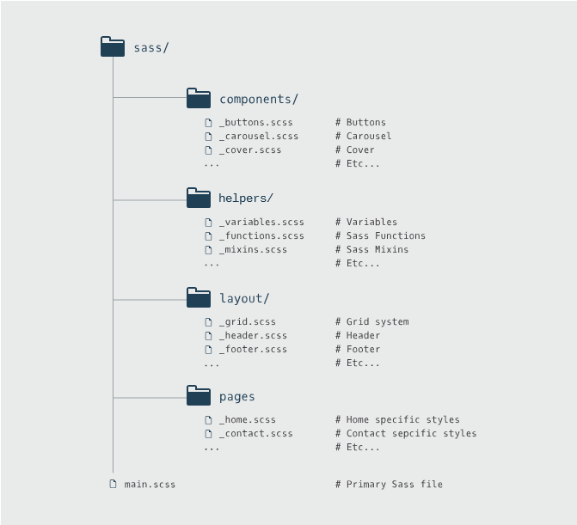
It’s good practice to split up .scss files into multiple well organised, clearly named files, to reduce total file length.

To include a separate .scss file, use @import “file/path”.
Any files to be included should be prefixed with an underscore, to let the SASS compiler know not to compile immediately.
This automatically searches for a .scss file with that path location, but will need specification if searching for a .css or url.

